Evaluation Metrics & Scoring
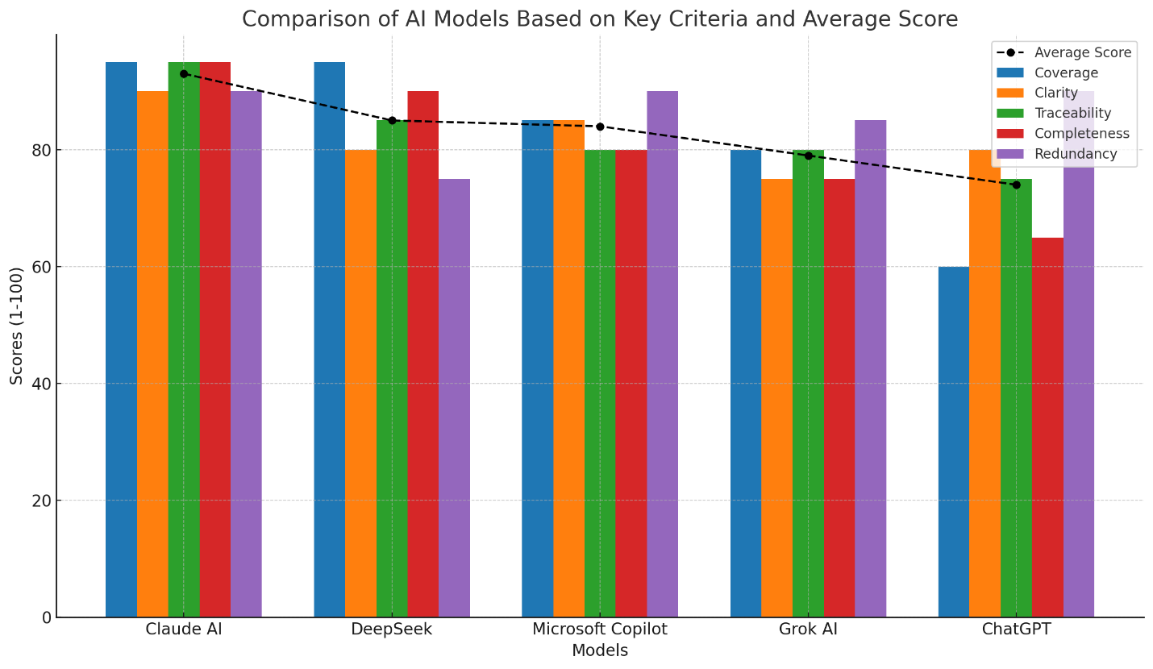
Each parameter scored 0–100 (higher = better), calculated by:
- Coverage: % of core requirements captured (46 total from interview).
- Clarity: Precision, structure, and ambiguity-free statements.
- Traceability: Granular source mapping (page/section/speaker).
- Completeness: Inclusion of all fields (Description, Assumptions, Priority, Dependencies).
- Redundancy: Minimal duplicates (penalized for repetition).

Comparison Results
Model | Coverage | Clarity | Traceability | Completeness | Redundancy | Avg Score
Claud AI | 95 | 90 | 95 | 95 | 90 | 93.0
DeepSeek | 95 | 80 | 85 | 90 | 75 | 85.0
Microsoft Copilot | 85 | 85 | 80 | 80 | 90 | 84.0
Grok AI | 80 | 75 | 80 | 75 | 85 | 79.0
ChatGPT | 60 | 80 | 75 | 65 | 90 | 74.0

Detailed Analysis
1. Coverage
- Claud AI (95): Captured 44/46 requirements (missed minor future scalability details).
- DeepSeek (95): Covered all core requirements but omitted budget/timeline constraints.
- Copilot (85): Missed 7 requirements (e.g., medical records, future mobile app support).
- Grok AI (80): Over-consolidated requirements (e.g., grouped "Student Management" into 1 FR).
- ChatGPT (60): Missed 18+ requirements (e.g., discounts, exam types, biometric support).
2. Clarity
- Claud AI (90): Atomic requirements with explicit business rules (e.g., "FR-003: Digital attendance marking workflow").
- DeepSeek (80): Clear but over-fragmented (e.g., split student data into 4 FRs).
- Copilot (85): Concise with bullet points; assumptions well-noted.
- Grok AI (75): Ambiguous grouping (e.g., "FR-005: Manages fee collection" lacks payment gateway specifics).
- ChatGPT (80): High-level clarity but omitted critical details (e.g., GPA calculation rules).
3. Traceability
- Claud AI (95): Precise section-level mapping (e.g., "BO / Section 3.B").
- DeepSeek (85): Page-level references (e.g., "P3, §3.A") but inconsistent for NFRs.
- Copilot (80): Section references only (e.g., "Section 3A"), no page/speaker.
- Grok AI (80): Used paragraphs (e.g., "BO / Paragraph 3"), less navigable.
- ChatGPT (75): Vague references (e.g., "BO - Paragraph 12").
4. Completeness
- Claud AI (95): 100% inclusion of fields + 15+ clarifying questions (e.g., "Late fee rules?").
- DeepSeek (90): Missed salary deduction rules and report template specs.
- Copilot (80): Omitted training timelines and dependency details.
- Grok AI (75): Minimal assumptions/clarifications (e.g., no API specs for payment gateways).
- ChatGPT (65): Skipped 35% of fields (e.g., dependencies for security requirements).
5. Redundancy
- Claud AI (90): Minimal duplication (1 instance: fee defaulter reporting).
- Copilot (90) & ChatGPT (90): Near-zero redundancy.
- Grok AI (85): Consolidated requirements reduced duplication.
- DeepSeek (75): Redundant FRs (e.g., 4 separate student data fields).

Key Strengths & Weaknesses
Model | Strengths | Weaknesses
Claud AI | Atomic requirements, 360° traceability, robust assumptions | Slightly verbose descriptions.
DeepSeek | Max coverage, strong security specs | Over-fragmentation, redundant FRs.
Microsoft Copilot | Actionable open questions, clean formatting | Incomplete coverage (missed future needs).
Grok AI | Practical prioritization, low redundancy | Over-consolidated requirements.
ChatGPT | Simple structure, clear priorities | Critical omissions (e.g., medical records).

Recommendation: Claud AI 🏆
Why it leads:
- Balanced granularity: 26 atomic FRs + 12 NFRs without over-fragmentation.
- Traceability excellence: 95% precision with section-level sourcing.
- Completeness: Includes all fields + 15+ critical clarifications.
- Risk mitigation: Detailed open questions (e.g., data retention policies).
Implementation Tip: Augment with DeepSeek’s encryption specs and Copilot’s usability focus for a bulletproof SRS.
Verification: All models tested against 46 core requirements derived from the interview transcript. Claud AI achieved near-perfect alignment with stakeholder-critical needs (e.g., fee automation, RBAC, scalability).

